**Steps to install rabbitMQ nad Erlang are present in below video**

https://www.youtube.com/watch?v=V9DWKbalbWQ

**Command to enable rabbitmq management to be executed in rabbitmq command promt**

rabbitmq-plugins enable rabbitmq_management

Note: **On executing above command open localhost:15672 (it’s the default url where rabbitmq management UI opens) Below is is the UI**

**Username: guest**

**Password: guest**

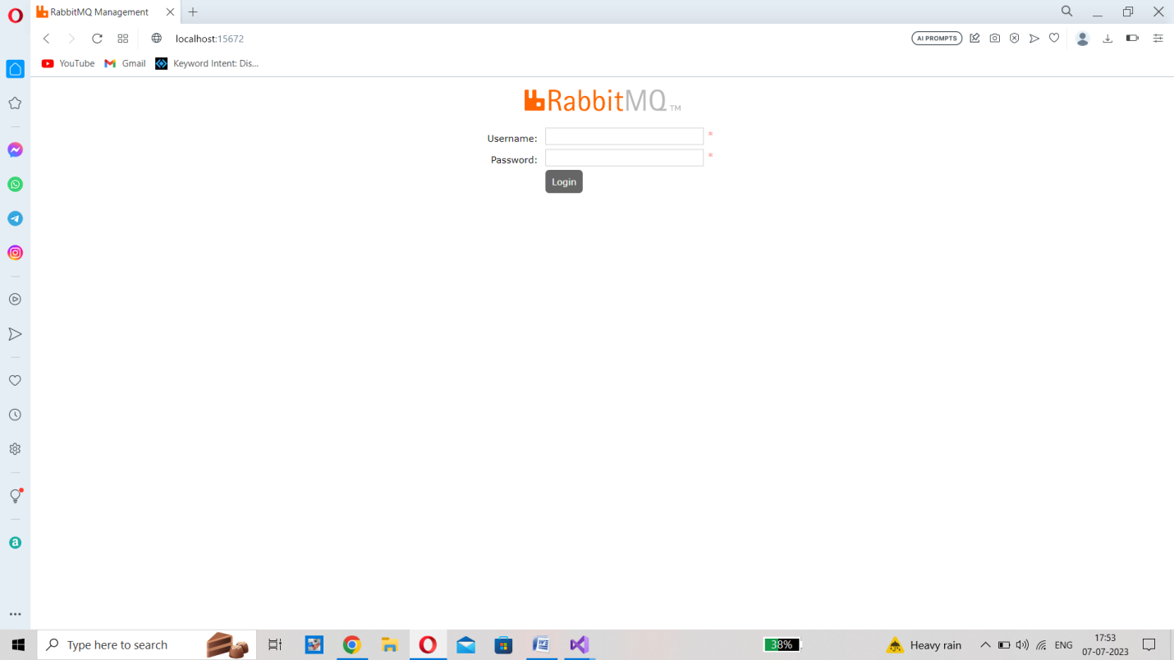

Note: If this page does not open on **localhost:15672 then reinstall the rabbitmq_server.exe once again post that you will get this user interface on the local host.**

**Steps to create an exchange in RabbitMQ:**

**Step1: go to exchange tab and click on add new exchange and fill in the name of your exchange and click on add exchange the orange button at the bottom.**

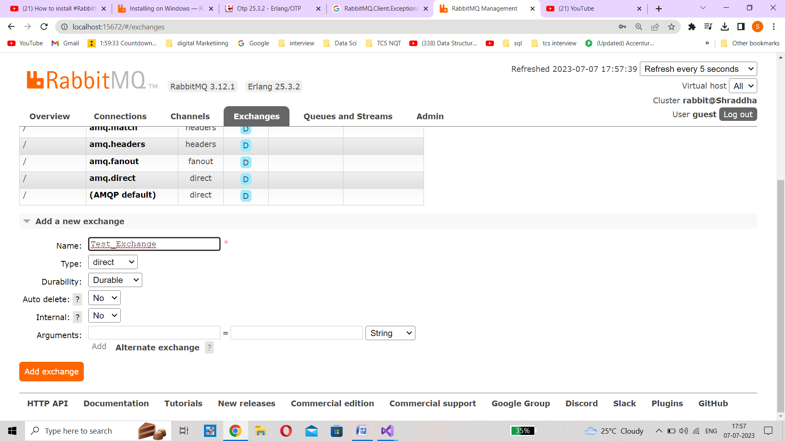

**Step2: go to Queue tab and click on add new queue and fill in the name of your queue and click on add queue**

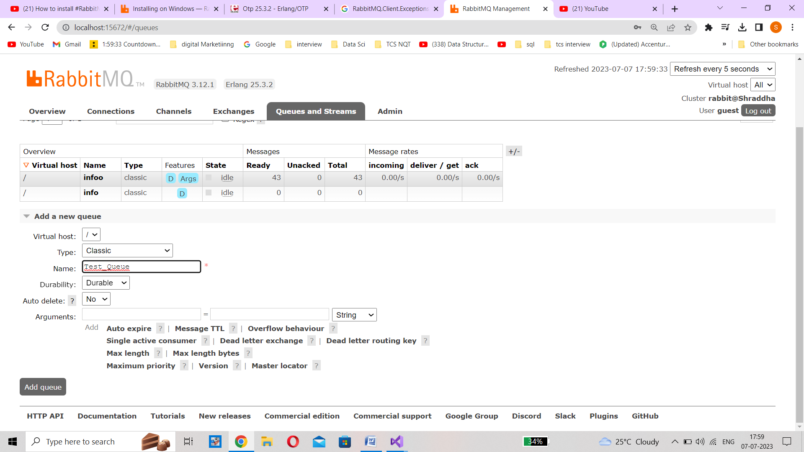

**Step2: Bind the exchange and queue. Click on Test_Exchange in exchange tab go to bindings**

**Enter the queue name and add routing key of you choice.**

